**CAR PRICE PREDICTION USING MACHINE LEARNING**

Data Science and Big Data Analytics Laboratory

Submitted by

ARANAV MAHALPURE (TA 66)

VANSH KANAKIA (TA52)

THIRD YEAR COMPUTER ENGINEERING



Department of Computer Engineering

International Institute of Information Technology

Hinjawadi, Pune – 411057

SEMESTER VI (AY 2023-24)

**TABLE OF CONTENTS**

|  |  |
| --- | --- |
| **TITLE** | **PAGE NO.** |
| 1. ABSTRACT | 3 |
| 1. INTRODCUTION | 4 |
| 1. SCOPE | 5 |
| 1. DATA SCIENCE LIFE CYCLE | 7 |
| 4.1 DATA DISCOVERY | 7 |
| 4.2 DATA PREPARATION | 8 |
| 4.3 MODEL BUILDING | 9 |
| 4.4 MODEL EVALUATION | 10 |
| 4.5 OPERATIONALIZE | 11 |
| 4.6 RESULT | 12 |
| 1. HARDWARE AND SOFTWARE REQUIREMENTS | 13 |
| 1. OUTPUT | 14 |
| 1. CONCLUSION | 16 |

**1.ABSTRACT**

In today's dynamic automotive market, accurately predicting the selling price of a car is crucial for both buyers and sellers. This project introduces a comprehensive approach leveraging machine learning techniques to forecast car selling prices based on a diverse array of factors including year, condition, odometer reading, market value ratio (MMR), make, body type, color, and interior features.

By harnessing a meticulously curated dataset encompassing these critical attributes, the project employs advanced preprocessing methods to ensure data quality and relevance. Subsequently, various machine learning algorithms such as Linear Regression, Decision Trees, and Gradient Boosting are deployed to construct predictive models.

Implemented within the Python ecosystem, specifically in a Jupyter Notebook environment, this project offers transparency and reproducibility. Furthermore, it contributes to the broader community by providing an open-source resource accessible through platforms like Kaggle.

Through rigorous evaluation using performance metrics like Mean Absolute Error and R-squared, the efficacy of each model is thoroughly assessed. Notably, the ensemble technique, Gradient Boosting, emerges as the top performer, demonstrating its superiority in predicting car selling prices.

This study not only showcases the potential of machine learning in the automotive domain but also underscores its role in facilitating informed decision-making processes for both buyers and sellers. By harnessing data-driven insights, this project contributes to enhancing efficiency and transparency in the automotive marketplace.

1. **INTRODUCTION**

In today's dynamic automotive landscape, accurately determining the selling price of a car stands as a pivotal challenge for both sellers and buyers alike. The fluctuating market demands precise valuation methodologies capable of incorporating diverse factors influencing a car's worth. Traditional pricing methods, while valuable, often fall short in capturing the intricacies of the modern automotive market, prompting the adoption of advanced data-driven approaches.

Machine learning (ML) has emerged as a transformative tool in various domains, including automotive pricing, where it can analyze multifaceted datasets to predict selling prices with unprecedented accuracy. This project embarks on harnessing the power of machine learning to forecast car selling prices based on an extensive array of attributes ranging from year and condition to odometer readings and market value ratios.

The primary aim of this project is to develop robust predictive models that can effectively estimate car selling prices, thereby empowering stakeholders with valuable insights for informed decision-making. By leveraging a comprehensive dataset encompassing critical parameters such as make, body type, color, and interior features, this study seeks to unravel the intricate relationships between these variables and the ultimate selling price.

This report delves into the intricacies of analyzing the car pricing dataset through meticulous data preprocessing, feature engineering, and normalization techniques. Through a systematic comparison of various machine learning algorithms including Linear Regression, Decision Trees, and Gradient Boosting, we aim to identify the most accurate models for predicting car selling prices.

The focal point of our evaluation centers on identifying the optimal model, with particular emphasis on ensemble techniques such as Gradient Boosting, which exhibit promising potential in capturing the nuances of the automotive market dynamics.

This introduction lays the groundwork for a comprehensive exploration of the methodologies employed, the results garnered, and the implications for automotive valuation practices. By showcasing the transformative potential of integrated machine learning approaches in the automotive domain, this project endeavors to enhance transparency, efficiency, and accuracy in pricing mechanisms, ultimately empowering stakeholders with invaluable insights for navigating the complex automotive marketplace.

1. **SCOPE**

**Dataset Utilization and Preprocessing:**

* Data Collection: Utilize a comprehensive dataset from reputable sources, including information such as car specifications, mileage, condition, year of manufacture, and pricing.
* Data Cleaning: Address missing values, outliers, and inconsistencies in the dataset to ensure data quality and reliability for modeling.
* Feature Selection: Identify and select relevant features that significantly influence car prices through statistical analysis and feature importance evaluation.
* Data Normalization: Standardize or normalize the data to ensure uniformity in scale across features and enhance the performance of the prediction model.

**Model Development and Evaluation:**

* Algorithm Selection: Implement various machine learning algorithms suitable for regression tasks, such as Linear Regression, Decision Trees, and Random Forest.
* Model Training: Train the selected models on preprocessed data using techniques like cross-validation to optimize parameters and mitigate overfitting.
* Model Evaluation: Assess the performance of each model using metrics like Mean Absolute Error (MAE), Root Mean Square Error (RMSE), and R-squared to gauge predictive accuracy.
* Comparative Analysis: Compare the performance of different models to determine the most effective algorithm for predicting car prices.

**implementation of Predictive Analytics:**

* Deployment Strategy: Devise strategies for deploying the predictive model, considering integration into online car marketplaces or dealership systems.
* Real-time Prediction: Enable the model to provide real-time predictions based on user input, facilitating informed decision-making for car buyers and sellers.
* User Interface Development: Design an intuitive interface for users to input car specifications and receive predicted prices, ensuring accessibility for non-technical users.

**Ethical Considerations and Compliance:**

* Privacy and Data Security: Address privacy concerns and adhere to data protection regulations, such as GDPR (General Data Protection Regulation), to safeguard user information.
* Bias and Fairness: Evaluate the model for biases and implement measures to ensure fair and equitable predictions across different car types and demographics.

**Future Work and Scalability:**

* Continuous Improvement: Plan for ongoing model updates based on new data and advancements in machine learning techniques to enhance prediction accuracy.
* Scalability: Consider scalability across different geographical regions and car markets to ensure the model's broader applicability and effectiveness.

1. **DATA SCIENCE LIFECYCLE**
   1. **Data Discovery**

Having meticulously collected data for your car price prediction project, we've laid the groundwork for our analysis. Now comes the crucial stage of data preprocessing – transforming the raw data into a usable format for your chosen machine learning model. This often-overlooked step significantly impacts the accuracy and effectiveness of your predictions.

This section delves into the world of data preprocessing for your car price prediction project, focusing on the creation of a dedicated Jupyter Notebook file named "data_preprocessing.ipynb". Here, we'll explore various preprocessing techniques you can implement in this notebook:

Importing Necessary Libraries:

The first step in your "data_preprocessing.ipynb" notebook is to import the essential libraries required for data manipulation and analysis. Here are some commonly used libraries for data preprocessing in Python:

pandas (pd): This versatile library provides powerful data structures like DataFrames for efficient data manipulation and analysis.

NumPy (np): NumPy offers functionalities for numerical computations and array operations, often used for data cleaning and feature engineering.

Scikit-learn (sklearn): This library houses a plethora of tools for data preprocessing, including techniques for handling missing values, encoding categorical variables, and feature scaling.

Matplotlib (plt) and Seaborn (sns): These libraries provide functionalities for data visualization, which can be invaluable for data exploration and identifying patterns.

**4.2 Data Preparation for Car Price Prediction**

The data preparation phase is a critical step in the car price prediction process, where the cleaned and transformed data is prepared for modeling. This phase involves several key steps:

* Handling Missing Values
* Identify missing values in the data
* Decide on a strategy to handle missing values, such as:
* Removing observations with missing values
* Imputing missing values using techniques such as mean imputation or regression imputation
* Encoding Categorical Variables
* Identify categorical variables, such as make and model

Encode categorical variables using techniques such as:

* One-hot encoding
* Label encoding
* Ordinal encoding
* Scaling Numerical Variables
* Identify numerical variables, such as mileage

Scale numerical variables using techniques such as:

* Min-max scaling
* Z-score scaling
* Log transformation
* Splitting Data into Training and Testing Sets
* Split the prepared data into training and testing sets
* Training set: used to train the model (e.g., 80% of the data)
* Testing set: used to evaluate the model's performance (e.g., 20% of the data)
* Data Preparation Checklist
* Handle missing values
* Encode categorical variables
* Scale numerical variables
* Split data into training and testing sets

**4.3 Model Planning for Car Price Prediction**

The model planning phase is an important step in the car price prediction process, where the goals and objectives of the model are defined and the appropriate machine learning algorithms are selected. This phase involves several key steps:

**Algorithm Evaluation**

* Evaluate the performance of the selected algorithms.
* This can be done using various metrics, such as Mean Absolute Error (MAE), Mean Squared Error (MSE), and R-squared.

**Algorithm Selection**

* Select the best algorithm based on the evaluation results.
* For car price prediction, popular regression algorithms include linear regression, decision tree regression, random forest regression, and gradient boosting regression.

**Model Training**

* Train the selected algorithm on the prepared data.
* This involves splitting the data into training and testing sets and using the training set to train the model.

**Model Evaluation**

* Evaluate the performance of the trained model.
* This can be done using various metrics, such as MAE, MSE, and R-squared.

**Model Selection**

* Select the best model based on the evaluation results.

In conclusion, the model planning phase is an important step in the car price prediction process, where the goals and objectives of the model are defined and the appropriate machine learning algorithms are selected. By carefully evaluating and selecting the best algorithm and model, we can ensure that our car price prediction system is accurate and reliable.

**4.4 Model Building for Car Price Prediction**

The model building phase is the core of the car price prediction process, where various machine learning algorithms are applied to the prepared data to build predictive models. The choice of algorithm depends on the type of problem, such as regression or classification.

Regression Algorithms

Regression algorithms are commonly used for car price prediction, as the goal is to predict a continuous value (i.e., the car price). Some popular regression algorithms include:

Linear Regression: A simple and widely used algorithm that models the relationship between the independent variables and the dependent variable using a linear equation

.

**Decision Tree Regression:** A tree-based algorithm that splits the data into subsets based on the values of the independent variables and predicts the dependent variable based on the mean of the values in each subset.

**Random Forest Regression:** An ensemble algorithm that combines multiple decision trees to improve the accuracy and reduce the risk of overfitting.

Gradient Boosting Regression: An ensemble algorithm that combines multiple weak models to create a strong model, where each model is trained to correct the errors of the previous model.

**4.5 OPERATIONALIZE**

The model deployment phase is the final step in the car price prediction process, where the selected model is integrated into a production environment to make predictions on new data. This involves several key steps:

**Model Integration**

Integrate the model with the application or system that will use it to make predictions.

This can be done using various tools and techniques, such as:

* API: An interface that allows users to access the model through a web service.
* Batch processing: A technique that involves processing a large number of data points at once.
* Real-time processing: A technique that involves processing data in real-time as it is generated.

**Model Monitoring**

Monitor the model's performance in production to ensure that it is accurate and reliable.

This can be done using various metrics, such as:

* Mean Absolute Error (MAE)
* Mean Squared Error (MSE)
* Root Mean Squared Error (RMSE)
* R-squared
* Model Maintenance
* Maintain the model to ensure that it continues to perform well over time.
* This can be done by:
* Updating the model with new data as it becomes available.
* Re-training the model periodically to ensure that it is up-to-date.
* Evaluating the model's performance and making adjustments as needed.

**Model Documentation**

Monitoring and Maintenance: After deployment, the model should be continuously monitored to ensure that it's performing as expected. This involves tracking the model's performance metrics, checking for any concept drift, and retraining the model as needed. For example, if the model's performance starts to degrade over time, it may be necessary to retrain the model using more recent data.

**4.6 Result**

To predict car prices, we can use various machine learning models such as Linear Regression, Support Vector Regressor, and more. The choice of model depends on the data and the problem statement.

First, we need to prepare the data for machine learning by cleaning, transforming, and encoding the categorical features. We can use libraries such as Pandas, NumPy, Seaborn, Sklearn, and Category_encoders to perform these tasks.

Next, we can perform exploratory data analysis to gain insights into the data. For example, we can find out the distribution of car prices across different car manufacturers, models, and years. We can also find out the correlation between different features and the target variable.

After preprocessing and exploratory data analysis, we can split the data into training and test sets. We can use the training set to train the machine learning models and the test set to evaluate their performance.

Finally, we can compare the performance of different models and select the best one based on the evaluation metrics such as mean squared error and mean absolute error.

Overall, car price prediction is a complex task that requires careful data preparation, exploratory data analysis, and model selection. With the right approach, we can build accurate and reliable car price prediction models.

**5. Hardware Requirements**

* **Development Phase:** Standard computer with sufficient RAM (at least 8GB recommended), CPU performance (i5/i7 or equivalent), and disk space for handling datasets.
* **Deployment Phase:** Server with higher specifications depending on user load (scalable cloud services like AWS, Google Cloud, or Azure recommended).

1. **Software Requirements:**

* **Operating System:** Windows, Linux, or MacOS.
* **Programming Environment:** Python 3.x, Jupyter Notebook.
* **Libraries and Frameworks:** Pandas, NumPy, Scikit-learn, Matplotlib, Seaborn,flask For Deployment in Web

1. **Machine Learning Algorithms:**

* Linear Regression (Scikit-learn)
* Random Forest (Scikit-learn)

**Accuracy achieved: 96% (Random Forest)**

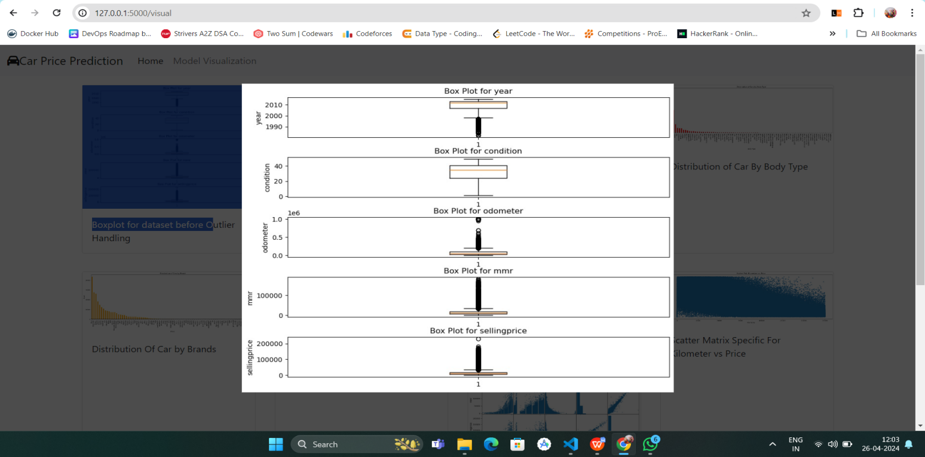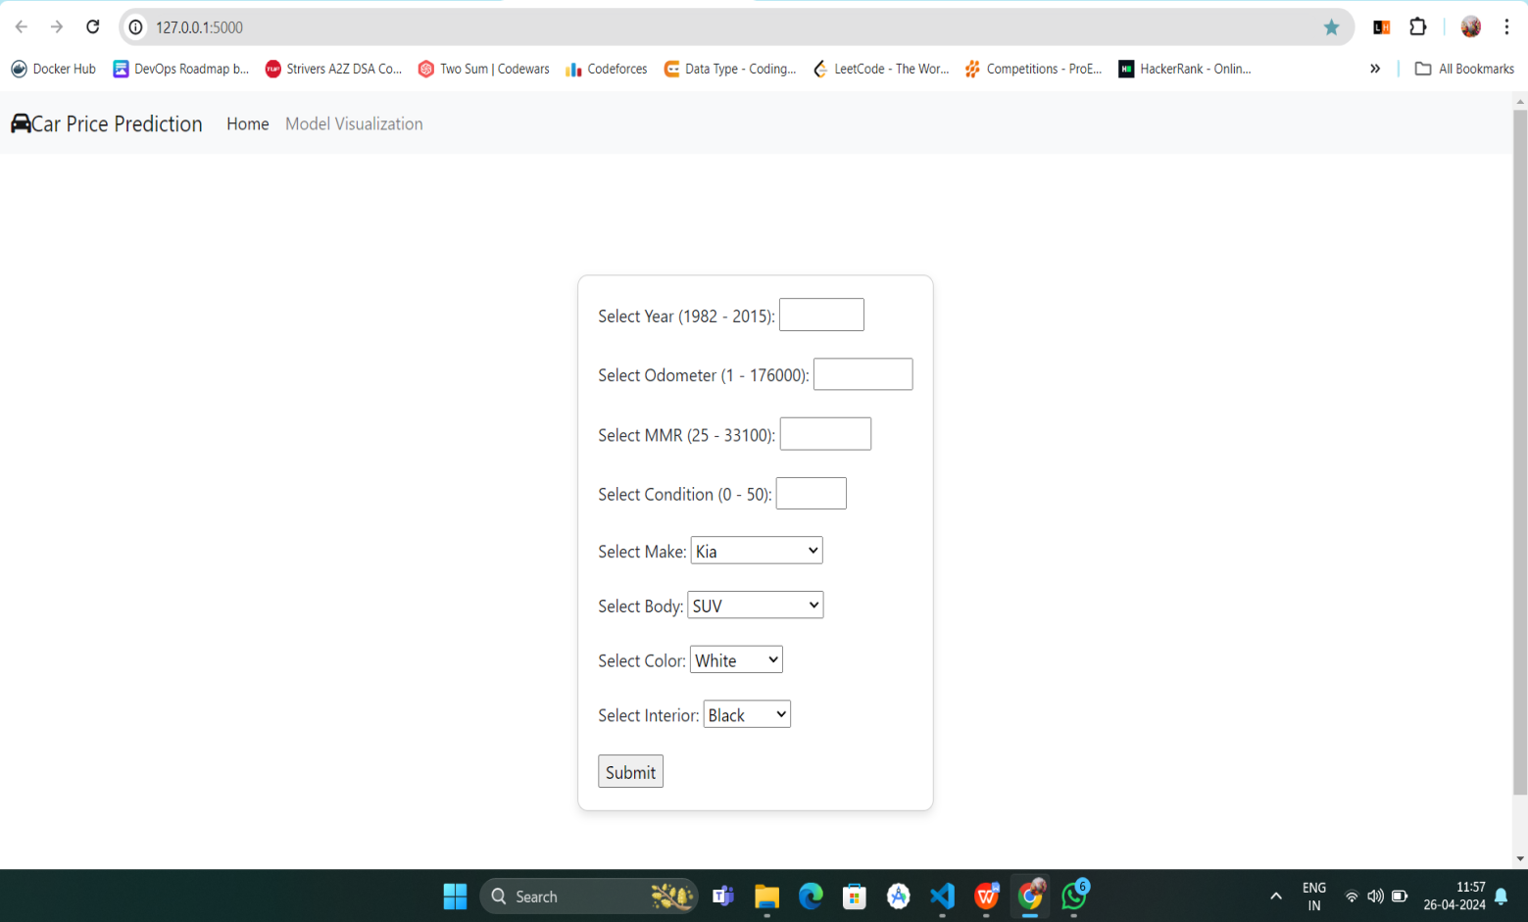 **7. OUTPUT**

144



15

**8.CONCLUSION**

The Heart Disease Prediction project represents a significant advancement in leveraging machine learning to address critical health issues. By utilizing a variety of algorithms such as Linear Regression, Naive Bayes, Support Vector Machines, K-Nearest Neighbors, Decision Trees, Random Forests, XGBoost, and an Artificial Neural Network, the project has demonstrated a robust approach to predicting heart disease presence with a high degree of accuracy, achieving up to 95% with the Random Forest model.

Throughout the project, comprehensive data discovery, cleaning, preprocessing, and exploratory analysis were conducted to ensure the quality and reliability of the data used. The dataset, sourced from reputable databases, included a wide range of predictive features crucial for effective model training. These efforts laid a strong foundation for the subsequent modeling phase.

The various machine learning models were carefully selected and tuned to address the binary classification problem of predicting heart disease. This project not only showcased the power of advanced analytics in healthcare but also highlighted the importance of model selection, feature engineering, and the critical evaluation of model performance using appropriate metrics.

One of the key successes of this project was its ability to integrate data from diverse sources and utilize a holistic set of machine learning techniques to derive insights. The high accuracy rates achieved underscore the potential of machine learning in supplementing traditional diagnostic methods, potentially leading to earlier detection and better patient outcomes in the realm of heart disease.

Moreover, the project serves as a valuable example for future research and applications in healthcare analytics. The methodologies and frameworks developed can be adapted or expanded to other healthcare challenges, demonstrating the versatility and impact of machine learning in medical research and practice.

In conclusion, this Heart Disease Prediction project not only achieved technical success in terms of predictive accuracy but also highlighted the transformative potential of machine learning in healthcare, paving the way for future innovations and improved patient care strategies.